**Analysis Summary**

The info in this report is deducted from the statistical analysis and visualization carried out in the attached Power BI file to answer the following questions:

1. 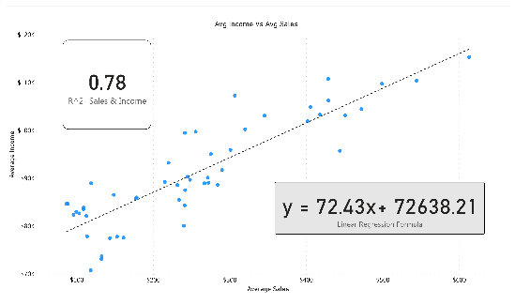***What is the correlation (R2 value) between sales and income?***

The “Avg Income Vs Avg Sales” visual shows a positive correlation between sales and income with (R2) equals 0.78 indicating a strong correlation.

1. 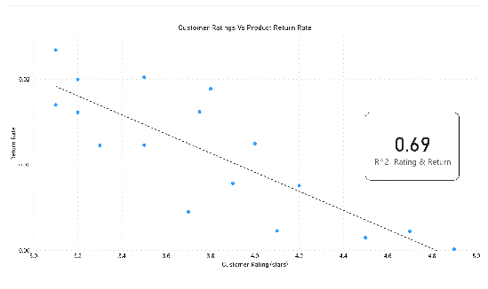***What is the correlation (R2 value) between customer ratings and product return rate?***

The “Customer Ratings Vs Product Return Rate” visual shows a negative correlation between customer ratings and product return rate with (R2) equals 0.69 indicating a moderate correlation.

1. ***What are the linear regression formulas to predict customer sales and customer incomes?***

y = mx + b m = 72.43 b = 72638.21

Therefore the final formula will be

y= 72.43x + 72638.21

The value of y (predicted customer income) can be calculated by substituting in the formula with x (customer sales) and vice versa.

1. ***Which customer do you predict has the highest income?***

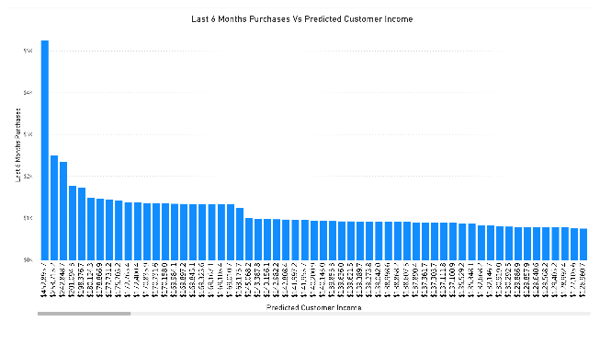As seen in the “Last 6 Months Purchases Vs Predicted Customer Income” visual, customers with the highest purchases have the highest income.

The highest predicted income was $452,895.7 in the state of Illinois with last 6 months purchases of $5,250.

1. ***Which product will be advertised the most?***

Since purchases are highly related to income, it is advisable to advertise the most expensive product (the leather bag) to high-income customers (above $130K) where almost all their last 6 months purchases exceeded $800.

Similarly, the sweater can be advertised to customers with income above $80K whose purchases exceeded $100.

The shirt, however, can be advertised to all customers, hence, this will be the product to advertise the most.

1. ***Additional Variables***

Additional 2 variables (Customer age & location) were analyzed as seen in the “Customer Demographics” report page. It was found that most customers are located in California and those made the highest purchases in the last six months.

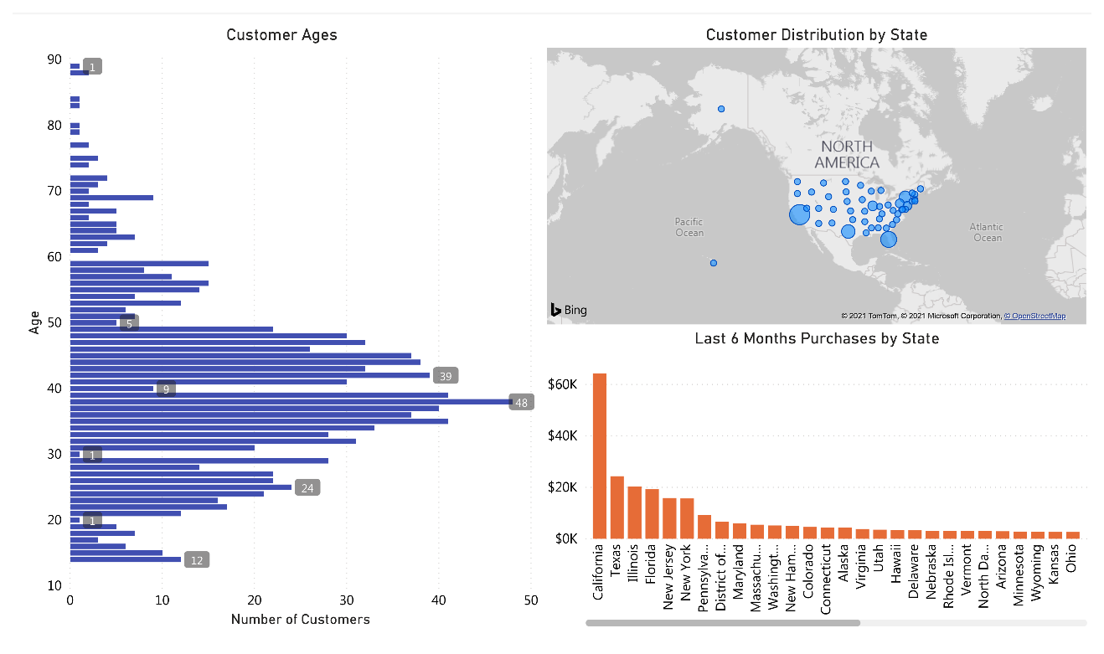It was also found that the age of most of the customers ranged from 35-45 years. It is highly recommended to consider these two variables in the marketing campaign.

1. ***Final Recommendations***
   * Advertise the *leather bag* to customers with income above $130K.
   * Advertise the *sweater* to customers with income above $80K.
   * Advertise the *shirt* to all customers.
   * Special focus of the marketing campaign on *age range 35-45* and *California* residents.